

**SCHOOL: COMPUTING AND INFORMATICS**

**DEPARTMENT: INFORMATION TECHNOLOGY**

**NAME: KILAMBO CHARLES KASUKU**

**ADM NO: CI/00064/014**

**COURSE: INFORMATION TECHNOLOGY**

**UNIT NAME: SOFTWARE PROJECT MANAGEMENT**

**UNIT CODE: CIT 401**

**LECTURER: MR SAM OONGE**

**DATE OF SUBMISSION: 13TH JANUARY 2018**

QUESTION ONE

A

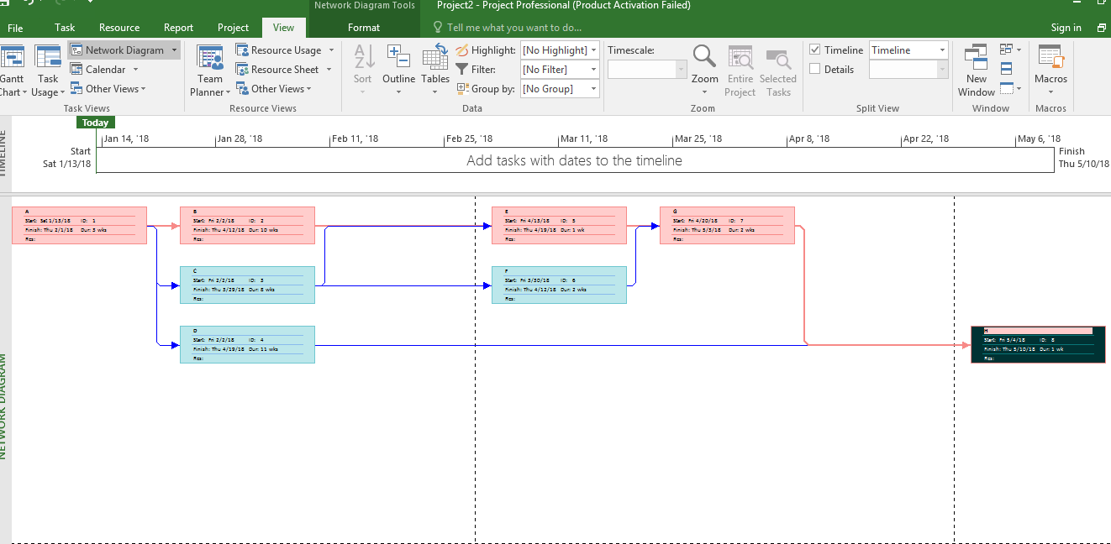

The minimum duration for the project is 17Weeks

Task A=3weeks

Task B=10weeks

Task E=1week

Task G=2weeks

Task H=1week

3+10+1+2+1=17weeks

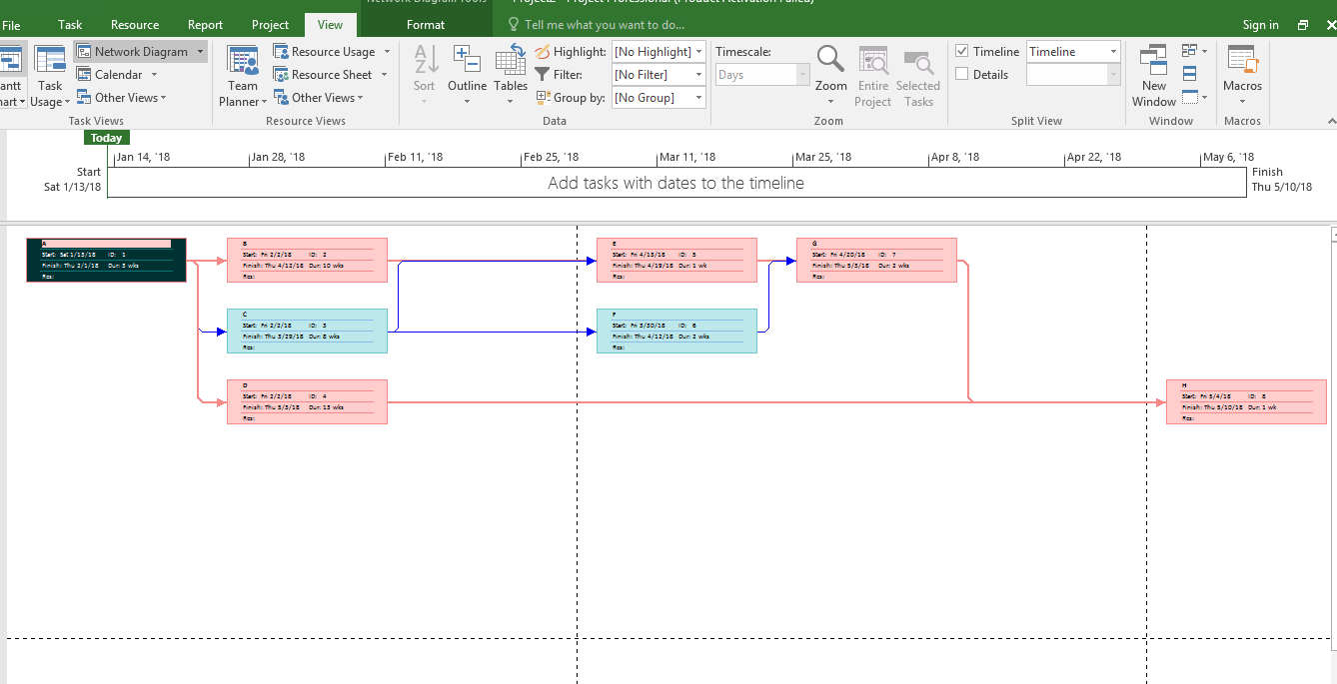Below is resultant activity-on-Node diagram after two weeks were added to task D

The above is the resultant diagram

The resultant will have two critical paths because two more weeks added to the A-D-H path will make it equal to the original critical path A-B-E-G-H of 17 weeks

Task A=3weeks

Task D= (11+2) weeks

Task H=1week

3+11+2+1=17weeks

And

Task A=3weeks

Task B=10weeks

Task E=1week

Task G=2weeks

Task H=1week

3+10+1+2+1=17weeks

C, The diagram below shows Gantt chart for revised project with arrows showing dependencies, float is zero and critical paths A-D-H and A-B-E-G-H

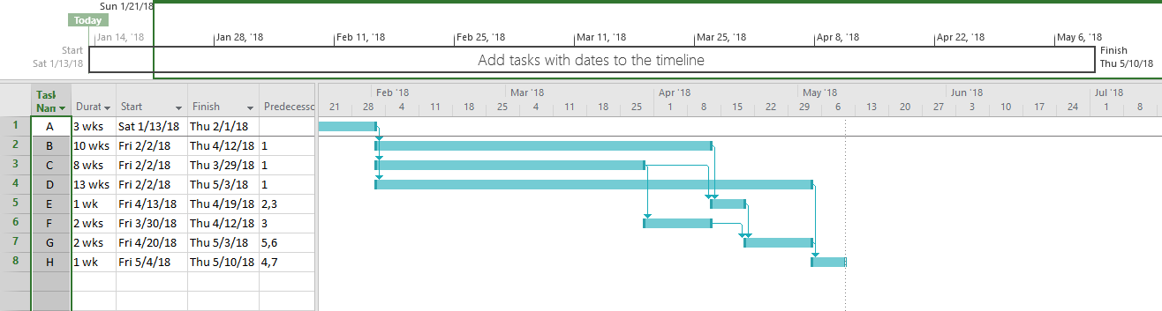

QUESTION 2

A,

Stakeholders are people who are involved in project activities who include the project sponsor, project team, support staff, customers, users, suppliers, and even opponents of the project. (According to Kathy schwalbe).

B,

The type of stakeholders here will be;

**Suppliers**

These are stakeholders who provide raw materials to the project as it proceeds. Therefore after the change has been decided these stakeholders need to be informed on exact details on the items which need to be supplied. For example what data is more important into the main station before carrying out the data transfer?

**Opponents**

These are people who oppose the adjustments of to the project or even the whole project upon opposition the other stakeholders will know how best to impact the changes into the new idea like creating a new single database for the whole company.

**Project manager**

This stakeholder is responsible for contracting the project coordinating all the activities of the project. Therefore upon the changes the project manager is responsible for bringing unity among members so that they can work together toward having the single station.

**Project sponsors**

These are stakeholders who are responsible for funding the project costs and activities. Therefore as the new changes are being carried out, they should be done within the cost from project sponsors like the network being created should be one the project sponsors can handle fully.

**Project team**

These are stakeholders who ensure that the project materials are available at a given site, therefore when the company is being decentralized they should be informed on which materials are need from the various stations.

C, The project sponsors work hand in hand with

Project managers

The project team

Customers

D,

The Tuckman model describes five stages of team development: (According to Kathy schwalbe).

1. Forming- introduction of team members, either at the initiation of the team or as new members are introduced.

2. Storming- when team members have different opinions for how the team should operate.

3. Norming-when team members have developed a common working method, and cooperation and collaboration replace the conflict and mistrust of the previous phase.

4. Performing- when the emphasis is on reaching the team’s goals rather than working on team process. Relationships are settled, and team members are likely to build loyalty toward each other.

5. Adjourning- breaking-up of the team after it successfully reaches its goals and completes the work